A Journey from Family Challenges to Compassionate Care

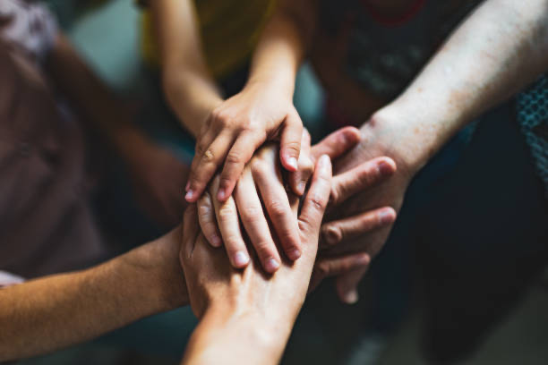
Mariana Garcia
Heritage University Department of Nursing
NURS 306: Family Nursing Inquiry

Introduction: A Journey shaped by Family and Culture
Growing up in a Hispanic household where my parents worked in agricultural jobs and lacked health insurance shaped my desire to pursue a career in nursing. Witnessing my family navigate these challenges ignited a passion within me to break down barriers and ensure that others do not face similar struggles.

Language Barriers: Bridging the Divide for Families like Mine

One of the most significant barriers I observed was the language divide that impacted my mother, who only spoke Spanish. The frustration and discomfort she experienced when communicating with healthcare providers emphasized my desire to become a nurse who could bridge this gap. During my clinicals last semester, I encountered many Spanish-speaking patients. Initially, I felt hesitant about my Spanish proficiency compared to my mother's fluency. However, one interaction with a patient's family member shifted my perspective. I noticed their relief and comfort when I spoke Spanish, which reminded me of my purpose in pursuing nursing. It reaffirmed my commitment to being that supportive figure for families who need understanding and assistance in navigating the healthcare system.

Finding My Voice: A Transformative Clinical Experience
A significant challenge my family faced recently was my father's diagnosis of two serious diseases. This situation tested our resilience as a family. At first, it was overwhelming for my dad, and it was a struggle for all of us. However, we came together, each playing a crucial role in his care. I took on the responsibility of managing his medications and picking them up at the pharmacy, while my mom focused on ensuring he received proper nutrition and assistance with mobility. My brother accompanied him to appointments, and my sister researched tools and devices that could help improve his quality of life. This experience highlighted the importance of my family values. We faced dark times, but we reminded each other that there is always light at the end of the tunnel. This journey taught me that challenges require patience and trust in the process. Resilience isn’t just about enduring; it’s about working together to find solutions.

A Family’s Resilience: Supporting My Father Through Illness
Family traditions in my life have revolved around togetherness, especially during difficult times. My father's recent health challenges affected each family member differently, with my mom experiencing caregiver strain from the stress and fatigue of managing his care. I have seen firsthand how illness impacts the entire family unit, reinforcing the need for a holistic approach in nursing. This reminded me of the family systems theory, where the family is viewed as a system composed of interrelated parts.

The Power of Family Systems in Nursing Care
My family nursing class has played a significant role in shaping my approach to care. I’ve learned how crucial it is to involve families in patient care. Healthcare providers often focus only on the patient’s main issue and forget about how illness affects the whole family. This realization changed my perspective. During a case study in the NIHC course, I encountered a scenario involving a concerned mother. My instinct was to address her anxieties and reassure her, but I noticed that many of the other professions did not consider the mother’s concerns, focusing solely on the child. This realization surprised me, as I, too, had once approached patient care with a narrow focus.

A New Perspective: The Importance of Family-Centered Care
As I envision my future role as a healthcare provider, I see myself as an advocate for both patients and their families. I aim to create an environment where families feel welcomed, informed, and involved in the care process. To ensure that families are included, I will prioritize open communication, provide educational resources, and practice cultural sensitivity. I recognize that illness affects not only the patient but also their loved ones, and I want to support them through these challenges.
With my experiences and the insights gained from my family nursing class, I believe my personal strengths will enhance my ability to work effectively with families. My empathy, strengthened by my own family’s challenges, allows me to connect deeply with patients and their families, validating their feelings and providing compassionate care. My family’s experiences have shown me that effective patient care often involves teamwork among healthcare providers and families. By modeling a positive outlook and focusing on potential solutions, I hope to empower families to navigate challenges together.

Conclusion: Embracing a Holistic Approach in My Nursing Career
In conclusion, my family nursing class and my personal experiences have shaped my understanding of the integral role families play in healthcare. As I move forward in my nursing career, I am committed to embracing family systems in my practice, ensuring that families feel heard, respected, and supported. By doing so, I hope to improve health outcomes for both patients and their loved ones, fostering a compassionate and inclusive healthcare environment.

REFERENCES
Denham, S., Eggenberger, S., Young, S., & Krumwiede, N. (2016). Family-focused Nursing
Care. Philadelphia, PA: FA Davis.

Kaakinen, J.R. & Coehlo, D. P., Steele, R., & Robinson, M. (2018). Family Health Care
Nursing: Theory, Practice, &Research. (6th ed.). Philadelphia, PA: FA Davis.

SanyaSM. (2020). Family holding hands [Photograph]. iStock.
https://www.istockphoto.com/photos/family-holding-hands

